Tender text SINEAX AM1000

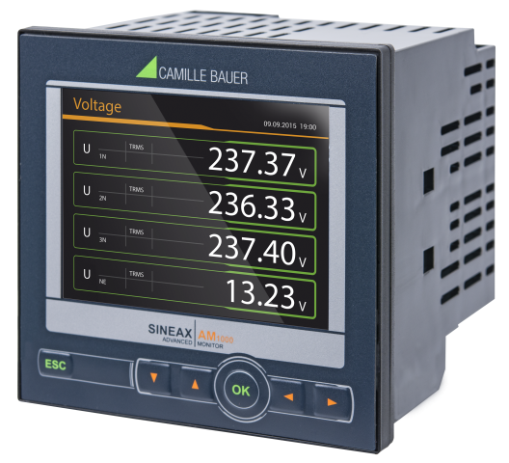
Transparent power quality and energy consumption monitoring
The SINEAX AM1000 is a compact instrument for measuring and monitoring in power distribution systems. It excels in display quality and intuitive operation. The devices provide a wide range of functionalities which may even be extended by optional components.
The modern, multi-lingual design allows operating and parameterizing the device via website or the high-resolution color TFT display (320x240px). The integrated webserver provides remote acquisition, visualization and analysis of measured data. No additional software is required.
Condition monitoring
- Provision of all voltages, currents, powers, power factors every 10/12 cycles
- Extended reactive power analysis
- Variance of system variables with time reference
Energy flow analysis
- Power mean-values with trend-analysis for preventing load-peaks
- Load profile storage with fluctuation range (min/max) per interval
- Active /reactive energy class 0.5S (HT/LT, demand/delivery), configurable resolution
- Further mean-values and meters with selectable base quantity
Power quality analysis
- Harmonic analysis acc. IEC 61000-4-7
- Assessment of voltage and current imbalance
- Phasor and phase sequence display for connection check
- Waveform display
- Optional disturbance recorder for PQ events (voltage dip, swell, interruption) acc. IEC 61000-4-30 Ed.3 with RMS1/2 and waveform recordings
Hardware option
Analog outputs ±20mA (2/4), Relay outputs (2), Digital inputs (4) active / passive, GPS time synchronization, Fault-current monitoring (residual or earth current), temperature monitoring (Pt100, PTC), IEC61850 or Profinet I/O
Communication
- Optional: Ethernet (Modbus/TCP, http/https, NTP, SFTP, SYSLOG), IEC61850, Profinet I/O, Modbus/RTU
- Scheduled data export to SFTP server (option Ethernet required)
Security (option Ethernet required)
- Flexible Role Based Access Control
- Encrypted communication via HTTPS
- Audit Log records all security related procedures, support for SYSLOG for transfer to central network monitoring server
- Client whitelist: IP address list for restricting authorized computers
- Digital firmware signature: Prevents that manipulated firmware gets into the device via update
Further features
- 3 current and 3 voltage channels with 0.2% accuracy, direct measurement or via transformers
- Measurement category 600V, CAT III (voltage), 300V,CAT III (current)
- Data logger with16 GB data memory (option)
- Sampling rate: 18kHz
- Monitoring and alarming via limit values and monitoring functions
- For panel mounting 96x96mm
- Identical operation as devices of the PQ/CU/DM series
Manufacturer
Camille Bauer Metrawatt AG
Aargauerstrasse 7
CH-5610 Wohlen
https://www.camillebauer.com/

