Tender text LINAX PQ1000

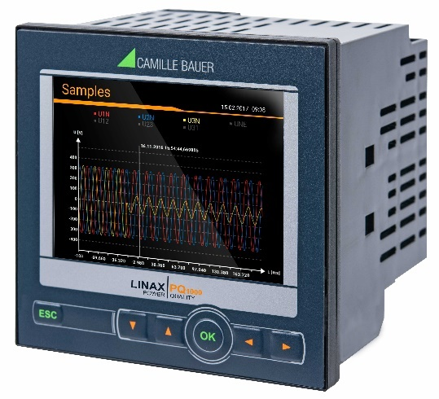
Transparent power quality and energy consumption monitoring
The LINAX PQ1000 combines the characteristics of a normative power quality measurement device with functions for energy consumption and condition monitoring.
The modern, multi-lingual design allows operating and parameterizing the device via website or the high-resolution color TFT display (320x240px). The integrated webserver provides remote acquisition, visualization and analysis of measured data. No additional software is required.
Power quality analysis
The device is intended to be used for a permanent power quality assessment according IEC 61000-4-30 Ed.3 in class S. The recorded events (voltage sag, voltage swell, voltage interruption, current swell, frequency change and homopolar voltage) serve both to prove that disturbances have occurred and to search for the origin of the disturbance in order to increase security of supply. Using the statistical voltage and current quantities, compliance with supply contracts or internal requirements can be verified. Assessment according EN 50160, IEC 61000-2-2/4/12, IEEE 519, GB/T or self-defined limits can be carried out after the measurement, corresponding conformity reports can be created via the device website (PQEasy-Report).
- Independent certification acc. IEC 62586-2 by Federal Institute of Metrology METAS
- Support for standardized, manufacturer independent PQDIF format acc. IEEE 1159.3
- Definable event recording duration: Up to 6 seconds for samples and 3 minutes for RMS values
- Event display via website with time zooming function and reading of values
Energy flow analysis
- Power mean-values with trend-analysis for preventing load-peaks
- Load profile storage with fluctuation range (min/max) per interval
- Active energy class 0.5S, Reactive energy class 0.5S (HT/LT, demand/delivery), configurable resolution
- Further mean-values and meters with selectable base quantity
Options
One modular extension: Analog outputs ±20mA (2/4), Relay outputs (2), Digital inputs (4) active / passive, GPS time synchronization, Fault-current monitoring (residual or earth current), temperature monitoring (Pt100, PTC), IEC61850, Profinet I/O
Communication
- Ethernet (Modbus/TCP, http/https, NTP, SFTP, SYSLOG)
- Optional: IEC61850, Profinet I/O, Modbus/RTU
- Scheduled data export (CSV and PQDIF files) to SFTP server
Security
- Flexible Role Based Access Control
- Encrypted communication via HTTPS
- Audit Log records all security related procedures, support for SYSLOG for transfer to central network monitoring server
- Client whitelist: IP address list for restricting authorized computers
- Digital firmware signature: Prevents that manipulated firmware gets into the device via update
Further features
- 3 current and 3 voltage channels with 0.2% accuracy, direct measurement or via transformers
- Measurement category 600V, CAT III (voltage), 300V,CAT III (current)
- 16 GB data memory
- Sampling rate: 18kHz
- Monitoring and alarming via limit values and monitoring functions
- For panel mounting 96x96mm
- Identical operation as devices of the AM/CU/DM series
Manufacturer
Camille Bauer Metrawatt AG
Aargauerstrasse 7
CH-5610 Wohlen
https://www.camillebauer.com/

