**Tender text SINEAX DM5000**

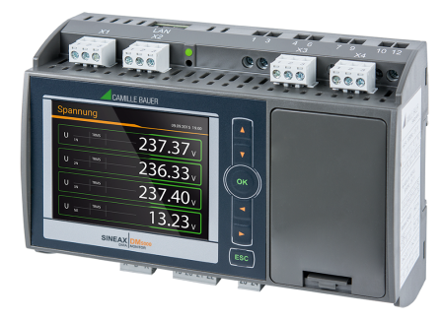

**Transparent power quality and energy consumption monitoring**

The SINEAX DM5000 is a compact instrument for measuring and monitoring in power distribution systems. It provides a wide range of functionalities which may even be extended by optional components. The connection of the process environment may be performed by communication interfaces, via digital I/Os, analog outputs or relays. The optional display excels in display quality and intuitive operation.

The device may be parameterized via webserver or the optional TFT display (320x240px). No additional software is required.

**Condition monitoring**

* Provision of all voltages, currents, powers, power factors every 10/12 cycles
* Extended reactive power analysis
* Variance of system variables with time reference

**Energy flow analysis**

* Power mean-values with trend-analysis for preventing load-peaks
* Load profile storage with fluctuation range (min/max) per interval
* Active energy class 0.2S, Reactive energy class 0.5S (HT/LT, demand/delivery), configurable resolution
* Further mean-values and meters with selectable base quantity

**Power quality analysis**

* Harmonic analysis acc. IEC 61000-4-7
* Assessment of voltage and current imbalance
* Phasor and phase sequence display for connection check
* Waveform display
* Optional disturbance recorder for PQ events (voltage dip, swell, interruption) acc. IEC 61000-4-30 Ed.3 with RMS1/2 and waveform recordings

**Hardware options**

Up to 2 modular extensions: Analog outputs ±20mA (2/4), Relay outputs (2), Digital inputs (4) active / passive, GPS time synchronization, Fault-current monitoring (residual or earth current), temperature monitoring (Pt100, PTC), IEC61850, Profinet I/O

**Communication**

* Ethernet (Modbus/TCP, http/https, NTP, SFTP, SYSLOG) and Modbus/RTU
* Optional: IEC61850, Profinet I/O
* Scheduled data export to SFTP server

**Security**

* Flexible Role Based Access Control
* Encrypted communication via HTTPS
* Audit Log records all security related procedures, support for SYSLOG for transfer to central network monitoring server
* Client whitelist: IP address list for restricting authorized computers
* Digital firmware signature: Prevents that manipulated firmware gets into the device via update

**Further features**

* 4 current and 4 voltage channels with 0.1% accuracy, direct measurement or via transformers
* Measurement category 600V, CAT III (voltage), 300V,CAT III (current)
* Optional UPS (5x3 minutes)
* Data logger with16 GB data memory (option)
* Sampling rate: 18kHz
* Monitoring and alarming via limit values and monitoring functions
* Device for hat-rail mounting 160x110x70mm
* Identical operation as devices of the PQ/CU/DM series

**Manufacturer**

Camille Bauer Metrawatt AG

Aargauerstrasse 7

CH-5610 Wohlen

<https://www.camillebauer.com/>