Tender text CENTRAX CU3000

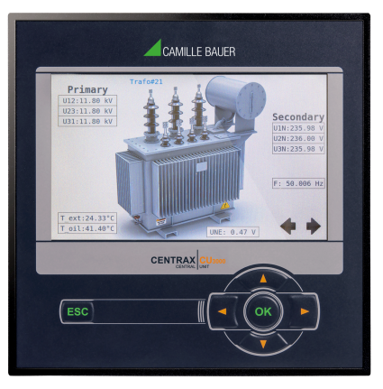
Transparent power quality and energy consumption monitoring
The CENTRAX CU3000 combines the functionality of a highly accurate instrument for heavy current applications with the possibilities of a freely programmable Soft-PLC in one housing. The connection of the process environment may be performed by communication interfaces, via digital I/Os, analog outputs or relays.
PLC functionality
- Based on Codesys, 3 performance classes
- BASIC: Flexible processing of the data of the measurement device using the complete I/O functionality
- ADVANCED: BASIC + Modbus RTU/TCP master and time-dependent processes
- PROFESSIONAL: ADVANCED + self-defined websites and local visualizations + Codesys data logger
Condition monitoring
- Provision of all voltages, currents, powers, power factors
- Variance of system variables with time reference
- Measurements of Modbus slaves
Energy flow analysis
- Power mean-values with trend-analysis for preventing load-peaks
- Load profile storage with fluctuation range (min/max) per interval
- Active energy class 0.2S, Reactive energy class 0.5S (HT/LT, demand/delivery), configurable resolution
- Further mean-values and meters with selectable base quantity
Power quality analysis
- Harmonic analysis acc. IEC 61000-4-7
- Assessment of voltage and current imbalance
- Phasor and phase sequence display for connection check
- Waveform display
- Optional disturbance recorder for PQ events (voltage dip, swell, interruption) acc. IEC 61000-4-30 Ed.3 with RMS1/2 and waveform recordings
Hardware options
Up to 4 modular extensions: Analog outputs ±20mA (2/4), relay outputs (2), digital inputs (4) active / passive, GPS time synchronization, fault-current monitoring (residual or earth current), temperature monitoring (Pt100, PTC), IEC61850
Communication
- Ethernet (Modbus/TCP, http/https, NTP, SFTP, SYSLOG)
- Modbus/RTU master or slave
- Optional: IEC61850
- Scheduled data export to SFTP server
Security
- Flexible Role Based Access Control
- Encrypted communication via HTTPS
- Audit Log records all security related procedures, support for SYSLOG for transfer to central network monitoring server
- Client whitelist: IP address list for restricting authorized computers
- Digital firmware signature: Prevents that manipulated firmware gets into the device via update
Further features
- 4 current and 4 voltage channels with 0.1% accuracy, direct measurement or via transformers
- Measurement category 600V, CAT III (voltage), 300V,CAT III (current)
- Optional UPS (5x3 minutes)
- Data logger with16 GB data memory (option)
- Sampling rate: 18kHz
- Monitoring and alarming via limit values and monitoring functions
- For panel mounting 144x144mm
- Identical operation as devices of the AM/PQ/DM series
Manufacturer
Camille Bauer Metrawatt AG
Aargauerstrasse 7
CH-5610 Wohlen
https://www.camillebauer.com/

